

CLOUD COMPUTING
BSE ( V-B )

Submitted By:
Musfira Farooq
Roll No:
2023-BSE-045

ASSIGNMENT 01
Git, Gitea, GitHub, LFS, and GitHub Pages

TASK 01
Run Gitea in Codespace and Create an Initial Repo
- Connecting to port:
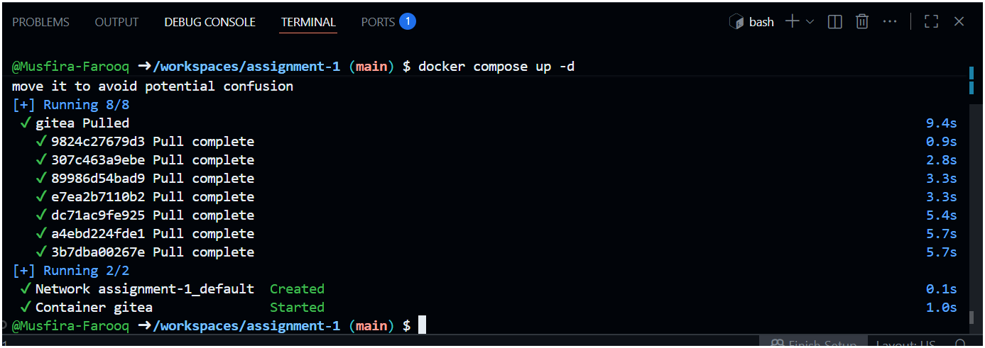
- Port 3000 web address:
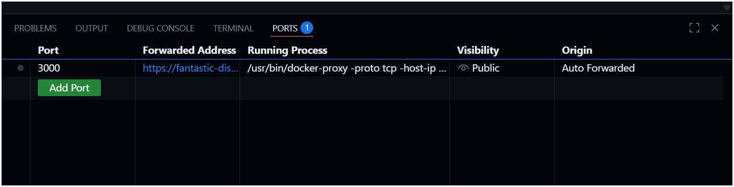
- Installing Gitea:
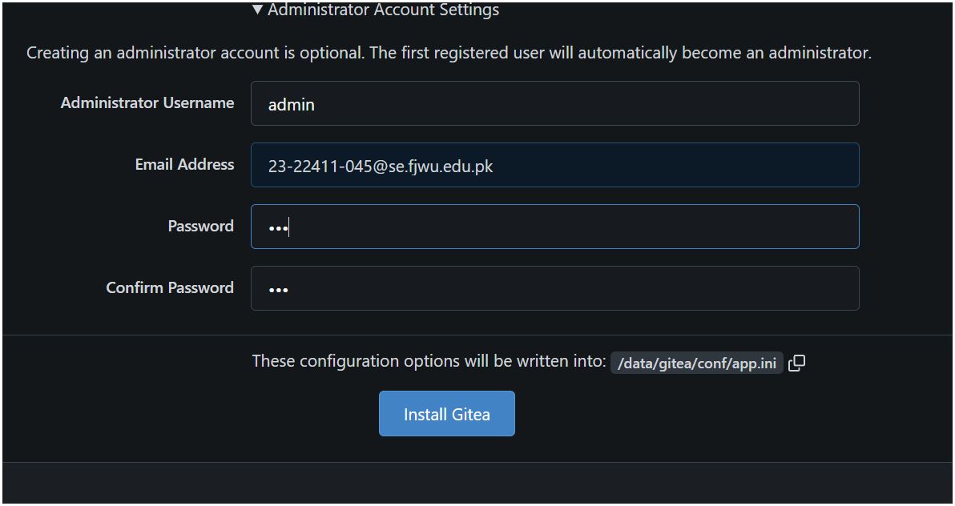
- Gitea Running in Codespace:
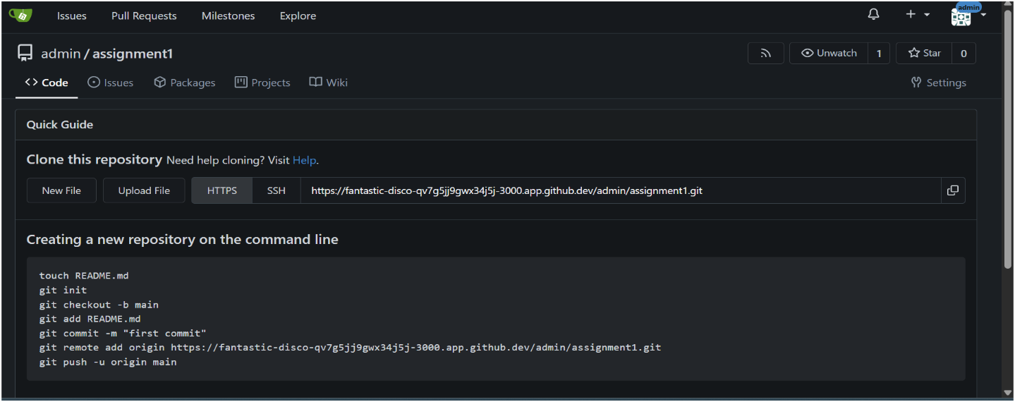
- Gitea Repository with README.md:
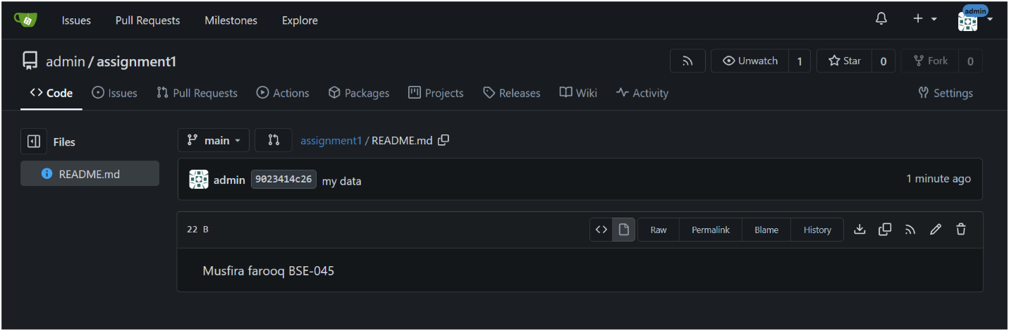
- Git Remote Command (Gitea Remote Added)
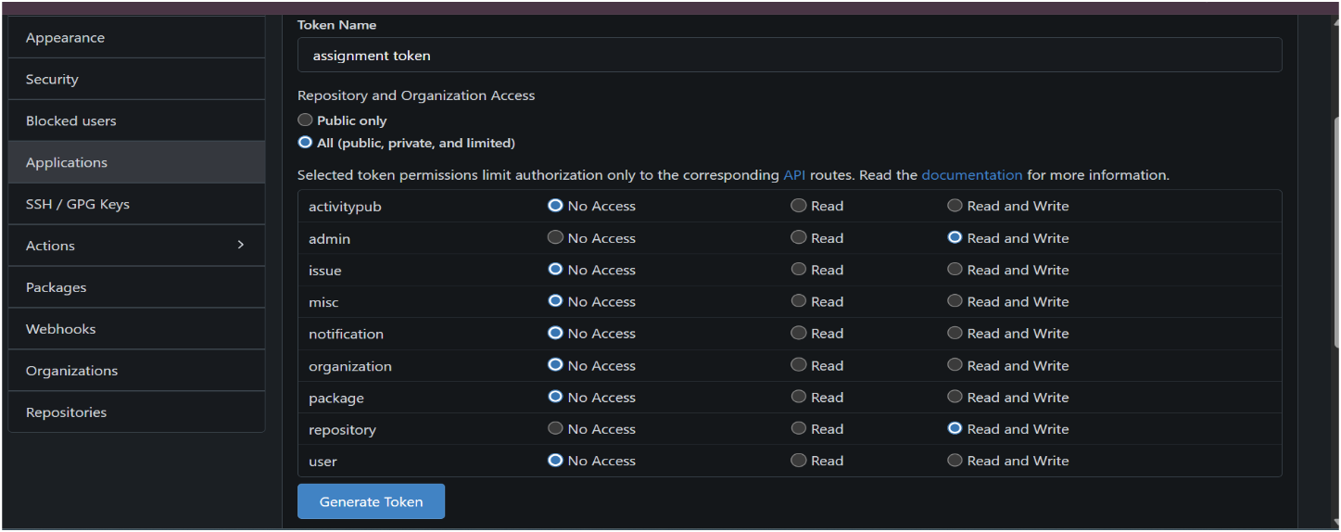
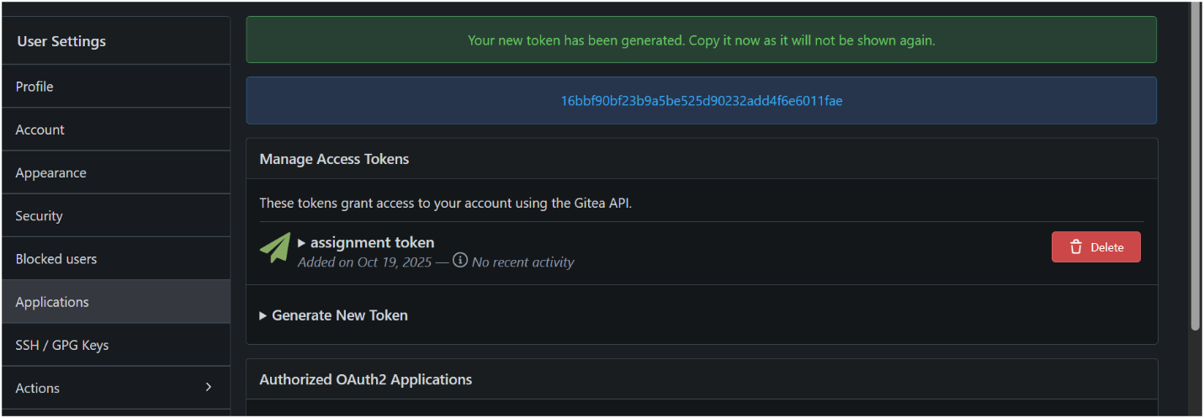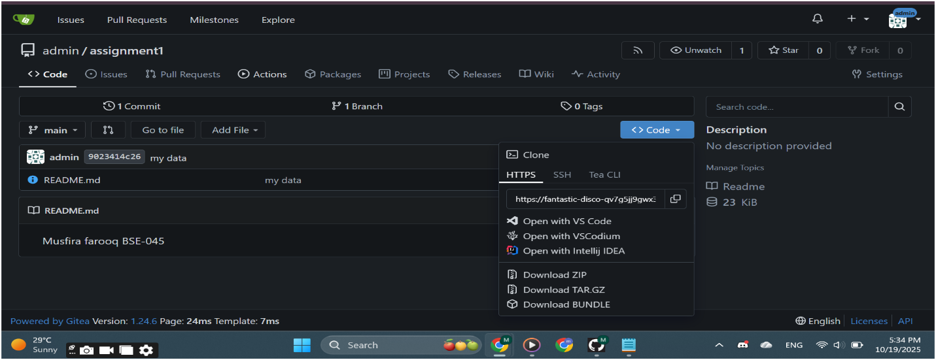
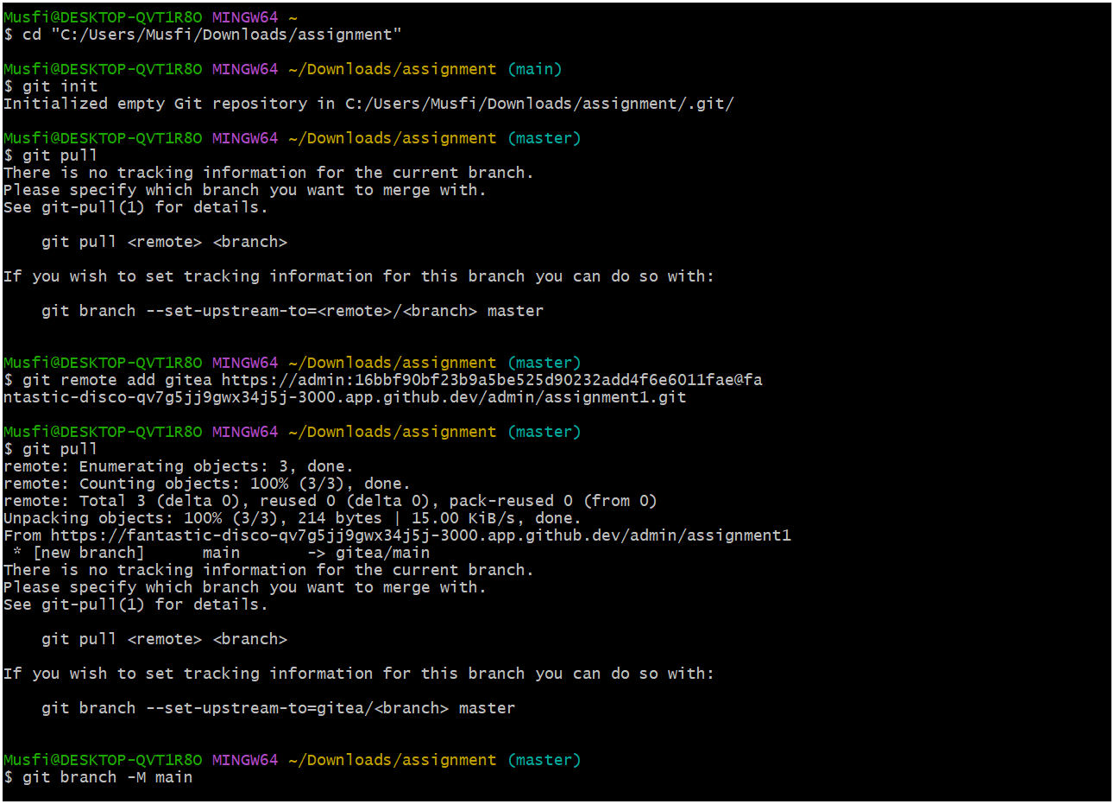
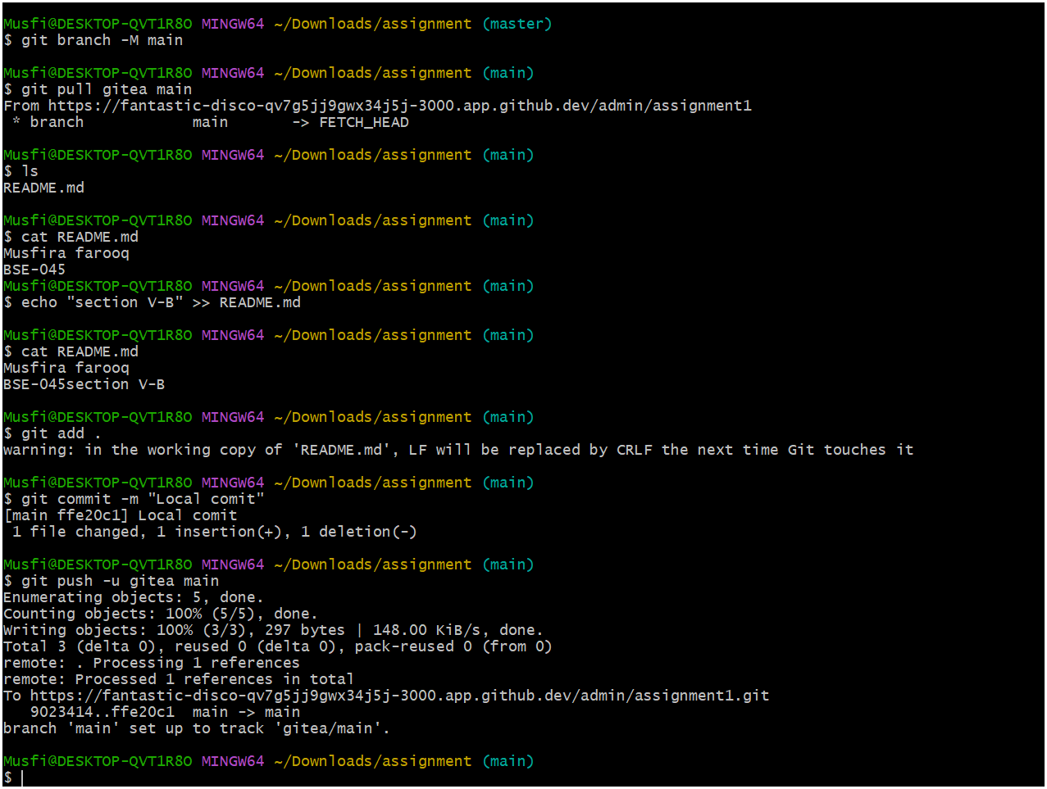
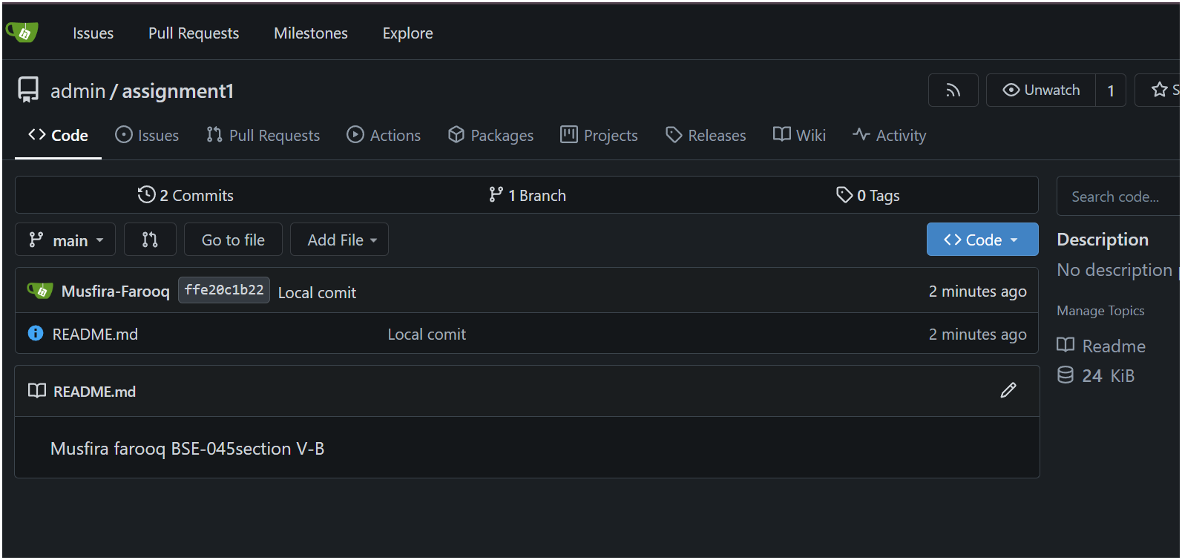
TASK 02
Mirror README.md from Gitea to GitHub
- GitHub Repository (assignment-1) with readme.md:
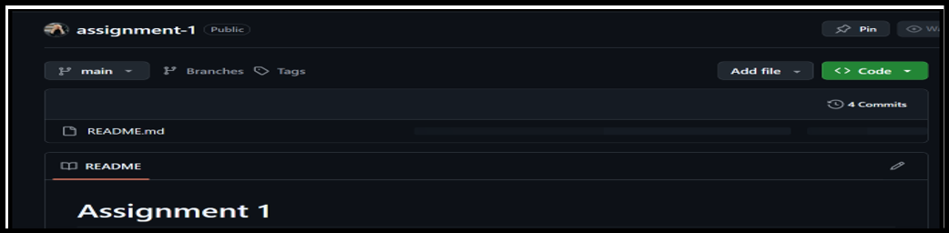
- Git Remote Command (Both Remotes):
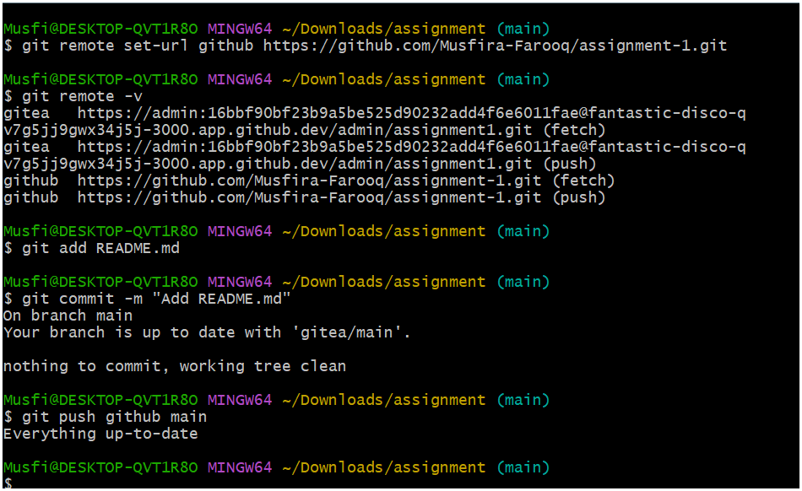
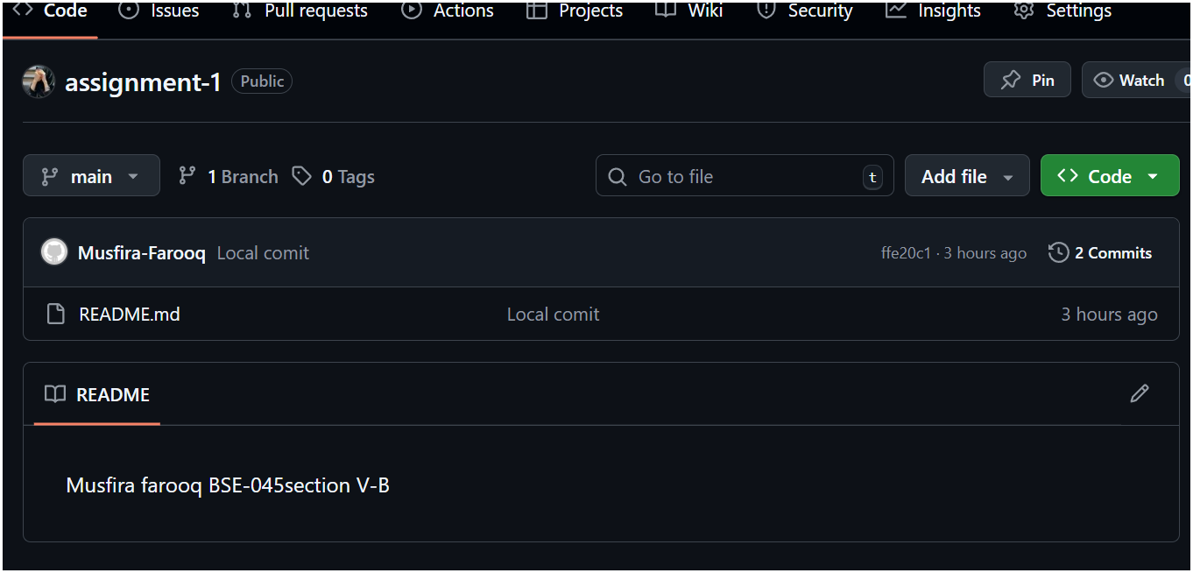
TASK 03
Use Git LFS for Large Files
- Git LFS Installation:
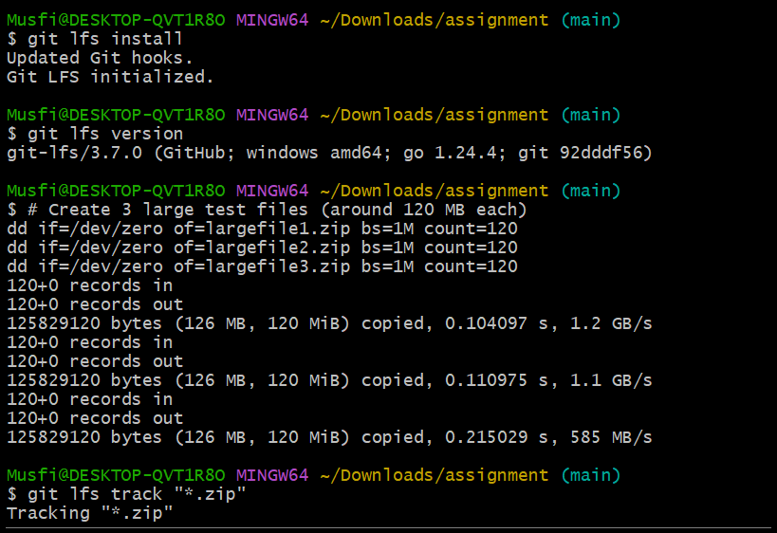
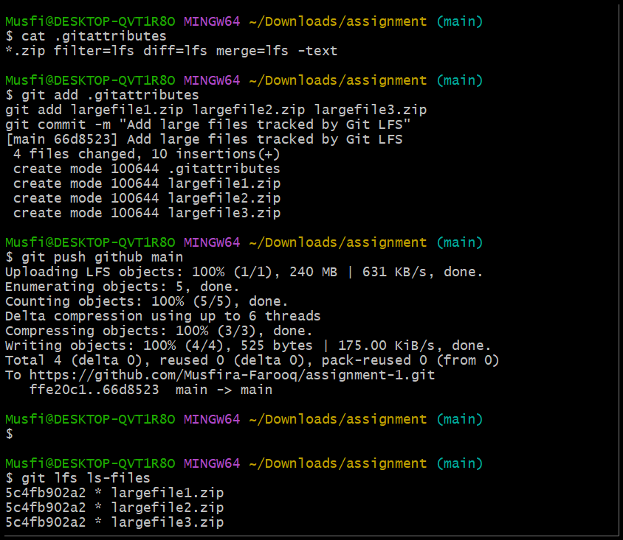
- GitHub Repository Showing Large Files:
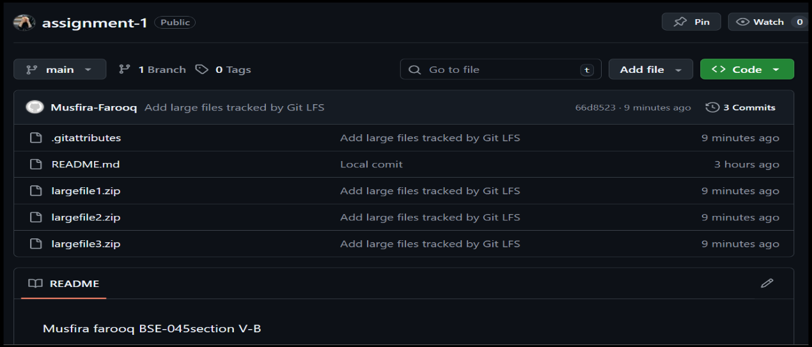
TASK 04
Create a Portfolio/CV with GitHub Pages
- GitHub Pages Repository:
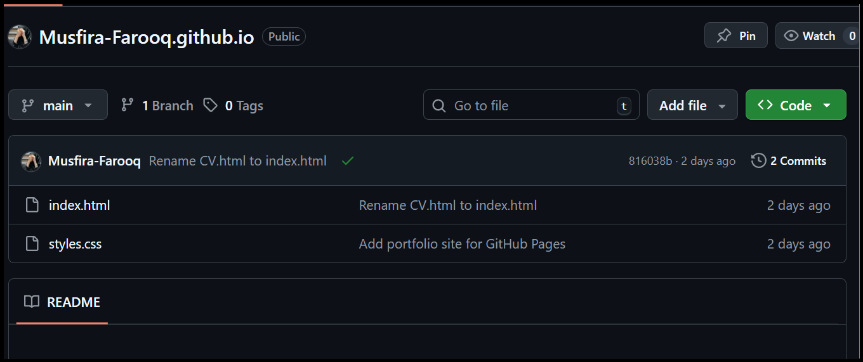
- GitHub Pages Settings:
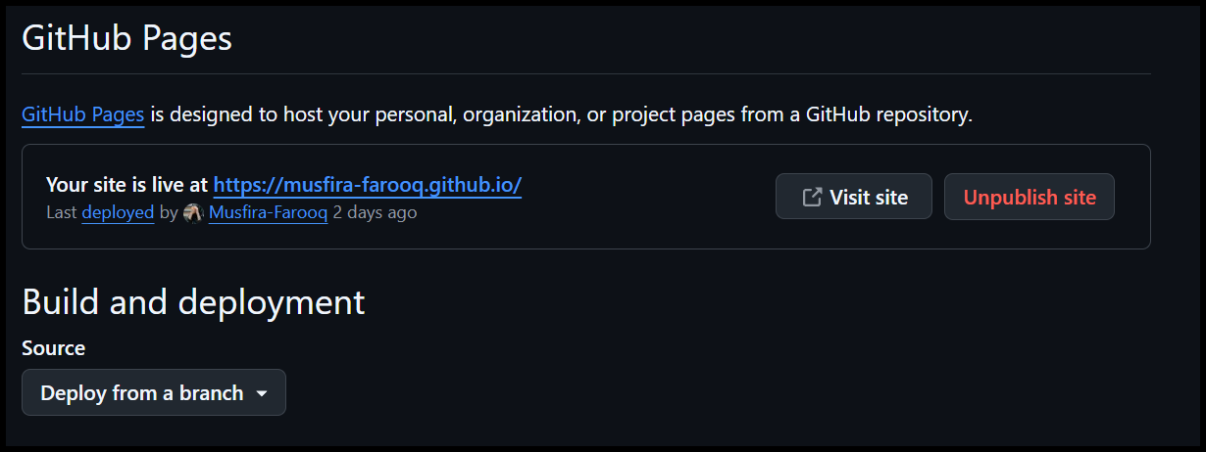
- Live CV Website:
https://musfira-farooq.github.io/
